Hobart HFPD (Hands Free Pager Device)

Table of Contents
Abstract 4
Bluetooth Low Energy (BLE) Advertisements 5
Information Blocks 5
Flags 5
Tx Power Level 5
Manufacturer Specific Data 6
Service Data 6
Shortened Local Name 6
Application Messaging 7
Introduction 7
Receive 8
Transmit 8
Commands 8
Get Firmware Version 8
Get OTA Number 8
Go to OTA Mode 9
Receive Message 9
Set Scale Number and Time 9
Clear Messages 9
Set Active Message Top 10
Set Active Message Bottom 10
Set Sleeping Message Top 10
Set Sleeping Message Bottom 10
Set User Name 11
Set Tx Power Level 11
Set Shift Duration 11
Set Low Power Counts 11
Set Advert Delay 11
Set Beep Time 12
Get Beeper Configuration 12
Get Active Message Top 12
Get Active Message Bottom 13
Get Sleeping Message Top 13
Get Sleeping Message Bottom 13
Get Username 14
Set New Logo 14
HFPD Bootloader 16
Introduction 16
DFU Packages 17
Bluetooth DFU 18
DFU service 18
DFU Version 18
DFU Control Point 18
DFU Packet 20
DFU Controller Procedure 23
Serial DFU 24
Serial DFU Process 24
DFU Messages 25

Abstract
The HFPD is designed to extend the functionality of Hobart equipment by allowing users to perform handsfree login, contact supervisors, and receive diagnostic messages. The device uses Bluetooth Low Energy to communicate with other Hobart devices. This document outlines these messages and provides technical data regarding the functionality of the HFPD. The HFPD is powered by Nordic Semiconductor’s nrf52832 chip. It is developed using Nordic’s SDK 11 and soft device 132.

Bluetooth Low Energy (BLE) Advertisements

The HFPD broadcasts general device information using BLE adverts. There are two types of adverts sent out. The first type is a low power advert. These adverts have an 18-byte payload and are a reduced version of the high power adverts. The second type of advert is a high power advert. These adverts contain a 25-byte payload separated into five information blocks. Each block is identified with an 8-bit eir identification code.

Information Blocks
Low Power Advert:
[0 - 1] | [2-3] | [4-12] | [13-17]
Flags | Tx Power Level | Manufacturer Specific Data | Shortened Local Name

High Power Advert:
[0 - 1] | [2-3] | [4-15] | [16-19] | [20-24]
Flags | Tx Power Level | Manufacturer Specific Data | Service Data | Shortened Local Name

Flags
Total Size: 2 Bytes
Data Type ID: 0x01

[0] | [1]
0x01 | Flags

Flags conform to BLE EIR advertising standards. See Bluetooth Core Specification:Vol. 3, Part C, section 8.1.3 (v2.1 + EDR, 3.0 + HS and 4.0)Vol. 3, Part C, sections 11.1.3 and 18.1 (v4.0)Core Specification Supplement, Part A, section 1.3 for more information on flags.

Tx Power Level
Total Size: 2 Bytes
Data Type ID: 0x0A

[0] | [1]
0x0A | Tx Power Level

HFPD sends n low power adverts followed by a high power advert. The Tx Power level byte indicates the power level at which the advert was sent. Possible power levels are -40, -20, -16, -12, -8, -4, 0, and 4 dBm

Manufacturer Specific Data
Total Size: 12 Bytes
Data Type ID: 0xFF
Low Power Advert:
[4] | [5-6] | [7-12]
0xFF | Device Type | MAC Address

High Power Advert:
[4] | [5-6] | [7-12] | [13-14] | [15]
0xFF | Device Type | MAC Address | FW Version | Number of Unread Messages

The manufacturer specific data block contains 4 sets of information. The device type field contains either 0xAFF1 or 0xAFF0. Devices of type 0xAFF1 are equipped with a EInk display while devices of type 0xAFF0 do not. Bytes 7-12 contain the Bluetooth MAC address of the device. The firmware version is contained in bytes 13 and 14. Byte 13 contains the major revision while byte 14 contains the minor revision. e.g. 0x0103 is firmware version 1.3. The last byte of the manufacturer specific data contains the number of unread messages on the device.

Service Data
Total Size: 4 Bytes
Data Type ID: 0x16

[16] | [17-18] | [19]
0x16 | Battery Level ID | Battery Level

Service Data is used to broadcast the current battery level as a percent. The maximum value for the Battery level is 0x64 (100).

Shortened Local Name
Total Size: 5 Bytes
Data Type ID: 0x08

[20] | [21-24]
0x08 | ITWH

All devices are given local name of ITWH. This is to identify a device as a Hobart HFPD.

Application Messaging

Introduction
While the application is running, the HFPD is equipped with two characteristics to allow for the transmission and reception of messages.

Receive
The characteristic with the UUID of {0000fff8-0000-1000-8000-00805f9b34fb} is the Rx characteristic. The Rx characteristic accepts messages of 20 bytes, where the first byte is the command id and the last byte is a CRC checksum. The remaining bytes are used to transfer information to the device. The commands are outlined in the commands section.

Transmit
The characteristic with the UUID of {0000fff7-0000-1000-8000-00805f9b34fb} is the Tx characteristic. It is used to notify the user of successful or failed commands. Each packet will be 20 bytes long. The first byte will be the command id. The last byte will contain a CRC checksum. In the event of a failed command, the Tx characteristic will respond with the command id followed by the byte 0x99

Commands
All commands must be 20 bytes long.

Get Firmware Version
Command ID: 0x01
Upon reception of this message the device will reply with a message containing the firmware version of the device.
Command:
[0] | [1-18] | [19]
0x01 | N/A | CRC Checksum

Reply:
[0] | [1] | [2] | [3-18] | [19]
0x01 | FW Major Revision | FW Minor Revision | N/A | CRC Checksum

Get OTA Number
Command ID: 0x02
Upon reception of this message the device will reply with a message containing the OTA Number of the device.
Command:
[0] | [1-18] | [19]
0x02 | N/A | CRC Checksum

Reply:
[0] | [1-4] | [5-18] | [19]
0x01 | OTA Number | N/A | CRC Checksum

Go to OTA Mode
Command ID: 0x03

Causes the device to jump into the bootloader and enter OTA DFU (Over The Air Data Flash Upgrade) mode. In OTA mode the device waits for a controller to send an upgrade file. The device uses Nordic SDK 11 DFU services while in OTA mode
Command:
[0] | [1-18] | [19]
0x03 | N/A | CRC Checksum

Receive Message
Command ID: 0x04
This message adds a new notification message to the devices message queue and alerts the user of the reception of a new message. Must send Set IP and Time before sending Receive Message.
Command:
[0] | [1-16] | [17-18] | [19]
0x04 | uint8_t * Message | pad | CRC Checksum

Set Scale Number and Time
Command ID: 0x05
Sets the IP and Time for the next message sent. Must be sent prior to sending a Receive message. Time is displayed in the HH:MM:SS format. The scale number must be between 0 and 254. (0x0 =< scale_number <= 0xFE)
Command:
[0] | [1] | [2] | [3] | [4] | [5-18] | [19]
0x05 | uint8_t Scale Number | uint8_t Hours | uint8_t Min | uint8_t Sec | N/A | CRC Checksum

Clear Messages
Command ID: 0x06
Clears all messages from the devices message queue.
Command:
[0] | [1-18] | [19]
0x06 | N/A | CRC Checksum

Set Active Message Top
Command ID: 0x07
Sets the top line of the device active message. This message is restricted to ten characters due to screen size constraints.
Command:
[0] | [1-10] | [11-18] | [19]
0x07 | uint8_t * Message | pad | CRC Checksum

Set Active Message Bottom
Command ID: 0x08
Sets the bottom line of the device active message. This message is restricted to ten characters due to screen size constraints.
Command:
[0] | [1-10] | [11-18] | [19]
0x08 | uint8_t * Message | pad | CRC Checksum

Set Sleeping Message Top
Command ID: 0x09
Sets the top line of the device inactive message. This message is restricted to ten characters due to screen size constraints.
Command:
[0] | [1-10] | [11-18] | [19]
0x09 | uint8_t * Message | pad | CRC Checksum

Set Sleeping Message Bottom
Command ID: 0x0A
Sets the bottom line of the device inactive message. This message is restricted to ten characters due to screen size constraints.
Command:
[0] | [1-10] | [11-18] | [19]
0x0A | uint8_t * Message | pad | CRC Checksum

Set User Name
Command ID: 0x0B
Sets The user name for the device to the given value. The user name is displayed in the message field when there are no unread messages and the device is active.
Command:
[0] | [1-16] | [17-18] | [19]
0x0B | uint8_t * User Name | pad | CRC Checksum

Set Tx Power Level
Command ID: 0x0C
Sets the TX power level for the device. Accepted values are: -40, -20, -16, -12, -8, -4, 0, 4
Command:
[0] | [1] | [2-18] | [19]
0x0C | int8_t Tx Level | N/A | CRC Checksum

Set Shift Duration
Command ID: 0x0D
Sets the number of hours before automatic shutdown of the device. The timer is started when the device is powered on. Setting Shift Duration to 0 disables the shutdown timer. The maximum value for Shift Duration is 36 hours.
Command:
[0] | [1] | [2-18] | [19]
0x0D | uint8_t shift duration | N/A | CRC Checksum

Set Low Power Counts
Command ID: 0x0E
Sets the number of low power adverts sent before a high power advert is sent. Setting low power counts to 0 disables high power adverts. The maximum value for low power counts is 255.
Command:
[0] | [1] | [2-18] | [19]
0x0E | uint8_t counts | N/A | CRC Checksum

Set Advert Delay
Command ID: 0x0F
Sets the delay in milliseconds between advert broadcasts. The minimum delay is 100ms. The maximum delay is 10000ms.
Command:
[0] | [1-2] | [3-18] | [19]
0x0F | uint16_t delay | N/A | CRC Checksum

Set Beep Time
Command ID: 0x10
Sets the duration in milliseconds of the beep tone. Setting beep time to 0 disables the beeper. The maximum value for beep time is 255ms.
Command:
[0] | [1] | [2-18] | [19]
0x10 | uint8_t duration | N/A | CRC Checksum

Get Beeper Configuration
Command ID: 0x11
Gets the current configuration of the HFPD. The HFPD will reply with a message containing the current configuration value
Command:
[0] | [1-18] | [19]
0x11 | N/A | CRC Checksum

Reply:
[0] | [1] | [2] | [3-4] | [5] | [6] | [7-18] | [19]
0x11 | uint8_t shift duration in hours | uint8_t low power counts | uint16_t advert delay | uint8_t beep time | int8_t Tx Power Level | N/A | CRC Checksum

Get Active Message Top
Command ID: 0x12
Gets the top half of the active message of the HFPD. The HFPD will reply with a message containing the top half of the active message
Command:
[0] | [1-18] | [19]
0x12 | N/A | CRC Checksum

Reply:
[0] | [1-10] | [11-18] | [19]
0x12 | uint8_t [] active message top | N/A | CRC Checksum

Get Active Message Bottom
Command ID: 0x13
Gets the bottom half of the active message of the HFPD. The HFPD will reply with a message containing the bottom half of the active message
Command:
[0] | [1-18] | [19]
0x13 | N/A | CRC Checksum

Reply:
[0] | [1-10] | [11-18] | [19]
0x13 | uint8_t [] active message bottom | N/A | CRC Checksum

Get Sleeping Message Top
Command ID: 0x14
Gets the top half of the sleeping message of the HFPD. The HFPD will reply with a message containing the top half of the sleeping message
Command:
[0] | [1-18] | [19]
0x14 | N/A | CRC Checksum

Reply:
[0] | [1-10] | [11-18] | [19]
0x14 | uint8_t [] sleeping message top | N/A | CRC Checksum

Get Sleeping Message Bottom
Command ID: 0x15
Gets the bottom half of the sleeping message of the HFPD. The HFPD will reply with a message containing the bottom half of the sleeping message
Command:
[0] | [1-18] | [19]
0x15 | N/A | CRC Checksum

Reply:
[0] | [1-10] | [11-18] | [19]
0x15 | uint8_t [] sleeping message bottom | N/A | CRC Checksum

Get Username
Command ID: 0x16
Gets the username of the HFPD. The HFPD will reply with a message containing username for the HFPD
Command:
[0] | [1-18] | [19]
0x16 | N/A | CRC Checksum

Reply:
[0] | [1-16] | [17-18] | [19]
0x16 | uint8_t [] username | N/A | CRC Checksum

Set New Logo
Command IDs: 0x50-0x80
To set the logo a series of commands need to be sent. Sending 0x50 signals the start of the logo transfer and contains the first 16 bytes of the logo bitmap. The commands should then be sent in sequence until 0x80 is sent, signaling the end of the new logo. Once 0x80 is received the logo will be written to flash Each bit represents a pixel on the screen. Where bit 0 is the bottom left corner of the logo. The bits should be sent from bottom to top, left to right.
[0] | [1-17] | [18] | [19]
0x50 - 0x80 | uint8_t Logo[i - 0x50] | pad | CRC Checksum

Logo Example:

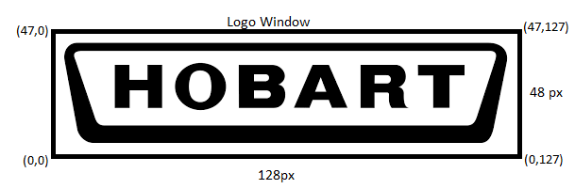

HFPD Bootloader

Introduction
The HFPD bootloader is used to upgrade the pager via Bluetooth Low Energy or by serial UART. It is built on top of Nordic Semiconductor’s bootloader included with SDK 11. To enter BLE DFU (Data Flash Upgrade) mode send the Go To OTA Mode command to a device running the application. Once the led stays solid green you are in BLE DFU mode. To enter Serial DFU mode hold the button of the front of the HFPD while booting the device. Once the led stays solid yellow you are in serial DFU mode. Application, Bootloader, and Softdevice upgrade packages can be generated using nrfutil. Upgrading erases the application section so it will need to be reprogramed after an upgrade.

DFU Packages
The creation of upgrade packages is done through Nordic Semiconductors’ nrfutil version 0.5.3. The utility can be found in the “.\ HFPD Vantron\Util\” folder. Upgrade packages can contain the application, softdevice and bootloader, softdevice or bootloader. Below are some sample commands to generate upgrade packages.
Bootloader:
python __main__.py dfu genpkg --bootloader "PATH_TO_BOOTLOADER\dfu_bootloader.hex" "PATH_TO_DESTINATION\IARHFPDBOOT.zip"
Application:
python __main__.py dfu genpkg --application "PATH_TO_APPLICATION\IARHFPD.hex" "PATH_TO_DESTINATION\IARHFPD.zip"
Softdevice:
python __main__.py dfu genpkg --softdevice "PATH_TO_SOFTDEVICE\ s132_nrf52_2.0.0_softdevice.hex" "PATH_TO_DESTINATION\IARHFPDSD.zip"
Bootloader and Softdevice:
python __main__.py dfu genpkg --bootloader "PATH_TO_BOOTLOADER\dfu_bootloader.hex" "PATH_TO_DESTINATION\IARHFPDBOOT.zip" --softdevice "PATH_TO_SOFTDEVICE\ s132_nrf52_2.0.0_softdevice.hex" "PATH_TO_DESTINATION\IARHFPDSD.zip"

Bluetooth DFU

DFU service
When in OTA mode HFPD advertises a DFU service UUID {00001530-1212-efde-1523-785feabcd123} This service provides three characteristics, DFU Packet, DFU Control Point, and DFU Version. Additional information regarding the Nordic DFU Service can be found in “Nordic Semiconductor DFU.pdf”

DFU Version
DFU version is a read only characteristic. It returns the DFU software version and a list of supported features.

DFU Control Point
DFU control point manipulates the state of HFPD in DFU mode. [1]Table 1 is taken from Nordic’s SDK 11 documentation. It indicates the op codes for the DFU Control point.
Table 1 [1]
Key | Value | Requirement | Description
0 | Reserved for future use
1 | Start DFU | C4 | Initiate the firmware update procedure. The response to this Op Code is a notification of the control point with Op Code 0x10, followed by the request Op Code 0x01 and the appropriate Response Value.
2 | Initialize DFU Parameters | C5 | Prepare to receive init packets. The response to this Op Code is a notification of the control point with Op Code 0x10, followed by the request Op Code 0x02 and the appropriate Response Value.
3 | Receive Firmware Image |  | Prepare to receive the firmware data. The response to this Op Code is a notification of the control point with Op Code 0x10, followed by the request Op Code 0x03 and the appropriate Response Value.
4 | Validate Firmware |  | Validate the received firmware. The response to this Op Code is a notification of the control point with Op Code 0x10, followed by the appropriate Response Value.
5 | Activate Image and Reset |  | Activate the previously received image and perform a system reset. There is no response to this Op Code.
6 | Reset System |  | Perform a system reset. There is no response to this Op Code.
7 | Report Received Image Size |  | Request the DFU target to report the total number of bytes of firmware data received (excluding the start data and init data). The response to this Op Code is a notification of the control point with Op Code 0x10, followed by the request Op Code 0x07, the appropriate Response Value, and the number of bytes in the Response Parameter.
8 | Packet Receipt Notification Request | C1 | Request the DFU target to enable/disable notifications of the control point characteristic each time the specified number of packets containing firmware data has been received. There is no response to this Op Code.
16 | Response Code | C2 | The Response Code is followed by the Request Op Code, the Response Value, and optionally the Response Parameter.
17 | Packet Receipt Notification | C3 | A notification sent by the DFU target indicating that a new set of the preconfigured number of firmware data packets has been received.
9-15 | Reserved for future use
18-255 | Reserved for future use

DFU Packet
DFU packet receives the data for the DFU bootloader. This characteristic receives data for Device Firmware Updates as DFU packets. DFU packets can contain different types of data, depending to the Op Code that is written to the DFU Control Point before the DFU packet is transmitted. [1] Table 2 shows possible DFU Packets.
Table 2
Names | Field requirement | Format | Additional information
Number of Packets  Information: Parameter value for the Packet Receipt Notification Request Op Code | C1 | uint16 | Number of packets of firmware data to be received by the DFU target before sending a new Packet Receipt Notification (control point notification with Op Code = 7). If this value is 0, the packet receipt notification will be disabled by the DFU target.
Request Op Code  Information: Parameter value for the Response Code Op Code | C2 | uint8 | Refer to the Op Code table above for additional information on the possible values for this field.
Response Value  Information: C2: This field is mandatory for the Response Code Op Code. Otherwise, this field is excluded. | C2 | uint8 | Enumerations:
  Key | Value | Description
  0 | Reserved for future use
  1 | Success | Response for successful operation.
  2 | Invalid State | The DFU controller has performed an operation that is not valid in the current state of the firmware update process.
  3 | Not Supported | The previous operation performed by the DFU controller or the data sent by the DFU controller is not supported.
  4 | Data Size Exceeds Limit | The DFU controller is trying to send more firmware data than expected.
  5 | CRC Error | A CRC error has occurred. This Response Value is used only by the Validate Firmware procedure.
  6 | Operation Failed | Response if the requested procedure failed.
  7-255 | Reserved for future use
Response Parameter  Information: C2: This field is optional for the Response Code Op Code. Otherwise, this field is excluded. | C2 | variable | Note: The Response Parameter of the response to the control point is a variable length field to allow a list of different values defined by the service specification.
Number of Bytes of Firmware Image Received  Information: C3: This field is present if the Op Code is 0x11 (Packet Receipt Notification). | C3 | uint32 | Number of bytes of firmware data (excluding the start and init data) received by the DFU target at the given point of time.
DFU Image Type  Information: C4: This field is present if the Op Code is 0x01 (Start DFU). This field is parsed as bit field where each bit that is set indicates the image transferred for the requested DFU. | C4 | uint8 | Enumerations:
  Key | Value | Description
  0x00 | No Image | No image will be updated.
  0x01 | SoftDevice | A SoftDevice image will be transferred.
  0x02 | Bootloader | A bootloader image will be transferred.
  0x03 | SoftDevice Bootloader | A SoftDevice with Bootloader image will be transferred.
  0x04 | Application | An application image will be transferred.
  0x05-0x07 | Other image combinations | Currently not supported.
  0x08-0xFF | Reserved for future use
DFU Init Packet  Information: C5: This field is present if the Op Code is 0x02 (Initialize DFU Parameters). | C5 | uint8 | Enumerations:
  Key | Value | Description
  0x00 | Receive Init Packet | Ready to receive the DFU init packet.
  0x01 | Init Packet Complete | Transmission of the DFU init packet is complete.

DFU Controller Procedure
Please see “Nordic Semiconductor Infocenter DFU Controller Procedure.pdf”, or https://infocenter.nordicsemi.com/index.jsp?topic=%2Fcom.nordic.infocenter.sdk5.v11.0.0%2Fexamples_ble_dfu.html for information regarding the Bluetooth DFU Controller

Serial DFU

Serial DFU Process
To put the HFPD into serial DFU mode hold the button while powering on the device. The HFPD will then wait for a start packet from the DFU controller. The start packet contains the update mode and the size of the bootloader, softdevice and application. The HFPD will ack each packet to continue the process. The controller will then send an init packet to the HFPD. After the init is acked the controller will send data packets until the image is sent. The HFPD will write the packets to flash memory and then ack each packet. After the final data packet is acked the controller will send a stop packet. The HFPD will verify the checksum of the upgrade and then ack the stop packet.
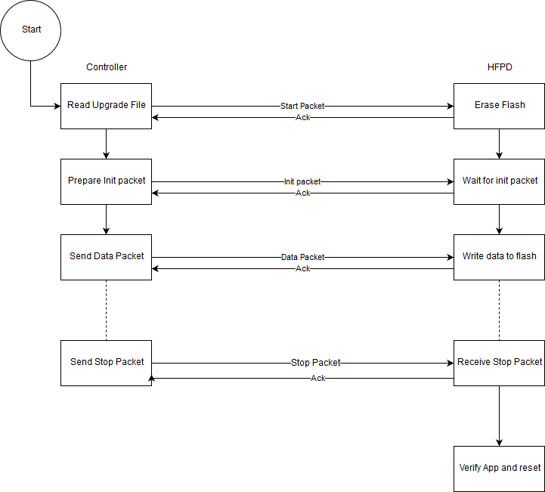

DFU Messages
Each message is bounded by 0xC0

HCI Header

The following figure illustrates the packet header [1]
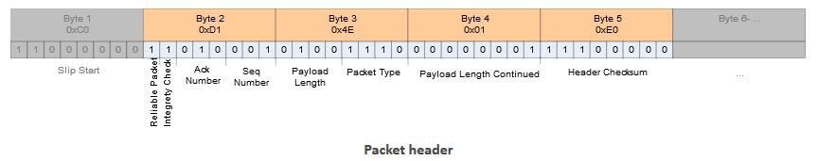

Start Packet
[0] | [1:4] | [5:8] | [9:12] | [13:16] | [17:21] | [22:25] | [26:27] | [28]
0xC0 | Hci header | DFU_START_PACKET | dfu_update_mode | sd_size | bl _size | app _size | crc | 0xC0

Init Packet
[0] | [1:4] | [5:8] | [9:12] | [13:14] | [15:16] | [17:18] | [19:n] | [n+1:n+2] | [n+3]
0xC0 | Hci header | DFU_INIT_PACKET | Application  version | Device  revision | Device  type | Softdevice  Req size | Softdevice req | crc | 0xC0

Data Packet
[0] | [1:4] | [5:8] | [9:520] | [521:522] | [523]
0xC0 | Hci header | DFU_DATA_PACKET | data | crc | 0xC0

Stop Packet
[0] | [1:4] | [5:8] | [9:10] | [11]
0xC0 | Hci header | DFU_STOP_PACKET | crc | 0xC0

Ack Packet
[0] | [1] | [2:3] | [4] | [5]
0xC0 | Packet number | pad | crc | 0xC0

